24ADC001 — BUSINESS INTELLIGENCE LAB ASSIGNMENT_21.08.2026
One scenario, one dataset, one tool each: Power BI, Tableau, OpenAI, and NotebookLM
LAB 1 — POWER BI

PedalShare: Building an OLAP Cube for a City Bike-Share Network
Concepts covered: data warehouse star schema, OLAP (roll-up, drill-down, slice, dice, pivot), analytic functions (DAX).

Scenario
PedalShare runs a bike-share network across Coimbatore, Chennai, and Bengaluru. Their ops team currently gets a single flat spreadsheet dump every morning and manually eyeballs it — there's no model, no drill-down, no way to compare cities or rider types quickly. You've been brought in to build them their first real analytical model: a proper star schema in Power BI that lets any manager slice the data six different ways before their coffee gets cold.

Dataset: pedalshare_trips.csv
- trip_id, date, city, station_start, rider_type (Member/Casual), bike_type (Classic/Electric), duration_min, weather, temperature_c
- Roughly 1,500 trips across 3 cities over a 90-day period, with real embedded patterns: casual riders take longer trips on weekends, rain shortens trips, and Bengaluru runs a higher volume than the other two cities.

Tasks
- Import the CSV and use Power Query to split it into a Fact_Trips table and at least two dimension tables (e.g., Dim_Date, Dim_City, Dim_RiderType).
- Build the relationships in Model view to complete the star schema.
- Build a Matrix visual with City on rows and Month/Week on columns, and use it to roll up to monthly totals and drill down to weekly, then daily detail.
- Add slicers for rider_type and weather. Produce one sliced view (a single weather condition) and one diced view (a specific city + rider type + weather combination).
- Write a DAX measure using RANKX() to rank stations by total trips, and a second measure computing average trip duration by rider type.
- Investigate: does casual ridership really spike on weekends across all three cities, or is that pattern driven by just one city? Show the visual that answers this.

Deliverables
- The .pbix file with the completed model, matrix visual, slicers, and both DAX measures.
- A short write-up answering the weekend-ridership investigation question, with a screenshot of the supporting visual.

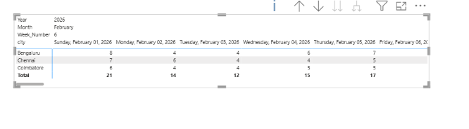
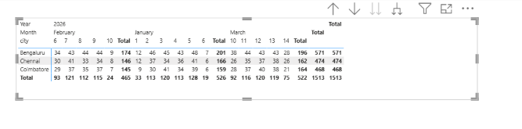
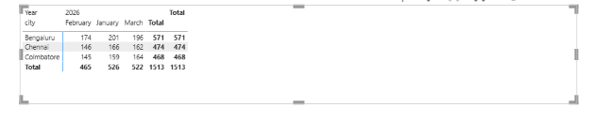
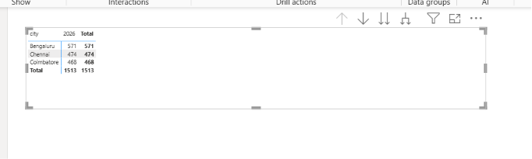
Drill through Roll up

Sliced View
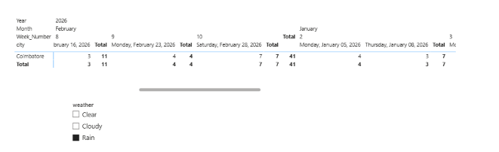

Diced view
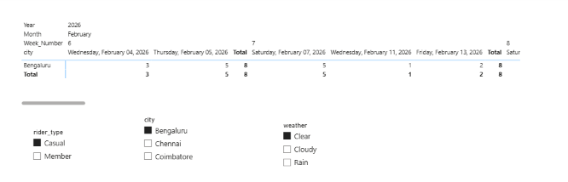
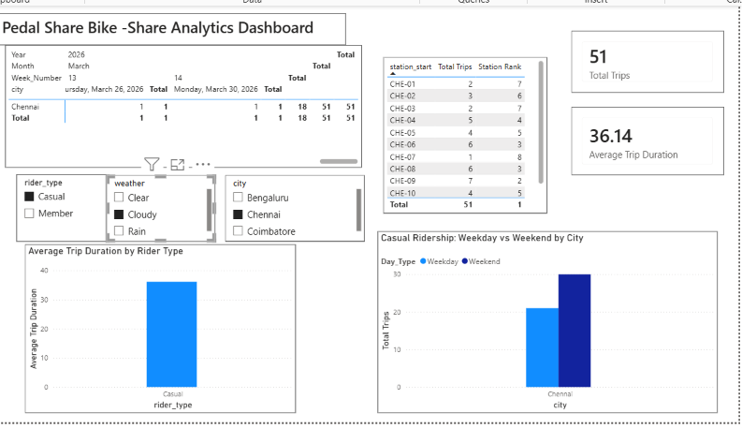

Filter the visual to Casual
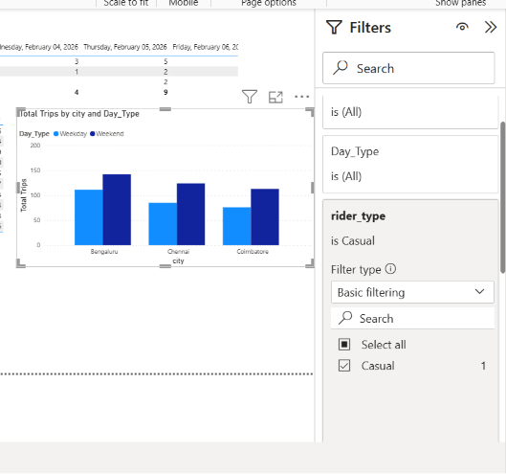

Final Dashboard
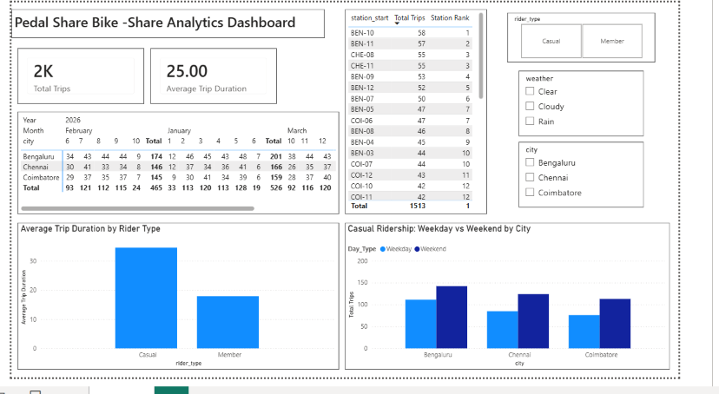

Weekend-Ridership Investigation
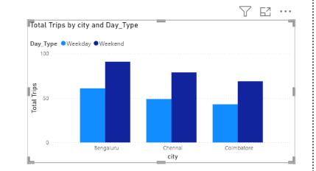

The weekday-vs-weekend comparison shows casual ridership rising on weekends in all three cities, not just one. In the unfiltered dataset, weekend trips exceed weekday trips for Bengaluru, Chennai, and Coimbatore alike. This pattern holds even under a rain-only filter, where weekend counts still edge out weekday counts across cities (e.g., Coimbatore ~13 weekday vs ~22 weekend). This indicates the weekend spike in casual ridership is a genuine network-wide behavioral pattern rather than an artifact of one city's data.

LAB 2 — TABLEAU CityCare Hospital: A Decision Support Dashboard for the Emergency Department
Concepts covered: business intelligence dashboards, decision support systems, types of decisions (structured/semi-structured/unstructured).

Scenario
CityCare Hospital's Emergency Department is chronically short-staffed at the worst possible times, and nobody can say with confidence when those times actually are. The department head has a hunch it's “weekend nights,” but hunches don't get budget approved. You've been asked to build a dashboard that turns the hunch into evidence — and to recommend, using it, what kind of decisionmaking process the hospital should actually use to solve the problem.

Dataset: citycare_er_visits.csv
- visit_id, date, arrival_hour, department, triage_level (1=most critical to 5=least), wait_time_min, age_group, outcome, day_of_week
- Roughly 1,700 visits over 120 days, with embedded patterns: wait times scale with triage severity, and weekend nights (6pm–11pm) run heavier volume with a wait-time surge.

Tasks
- Connect Tableau to the CSV and build three linked worksheets: a heatmap of visit volume by day-of-week × hour, a bar chart of average wait time by department, and a breakdown of outcomes by triage level.
- Build a drill-down hierarchy on Department → Triage Level, and demonstrate expanding and collapsing it.
- Add a filter for day-of-week and a parameter to toggle between viewing wait time vs. visit volume — use these to isolate the weekend-night pattern specifically.
- Create a calculated field ranking departments by average wait time using a table calculation.
- Combine the views into one dashboard with an action filter connecting them.
- Write a 200-word recommendation: is “when to add ER staff” a structured, semi-structured, or unstructured decision, based on what the dashboard actually shows? What role should a DSS play here versus a manager's judgment?

Deliverables
- The Tableau packaged workbook (.twbx).
- The 200-word written recommendation.

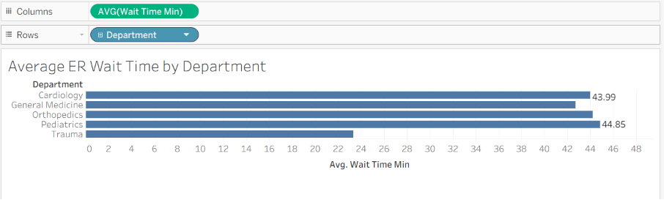
Drill down
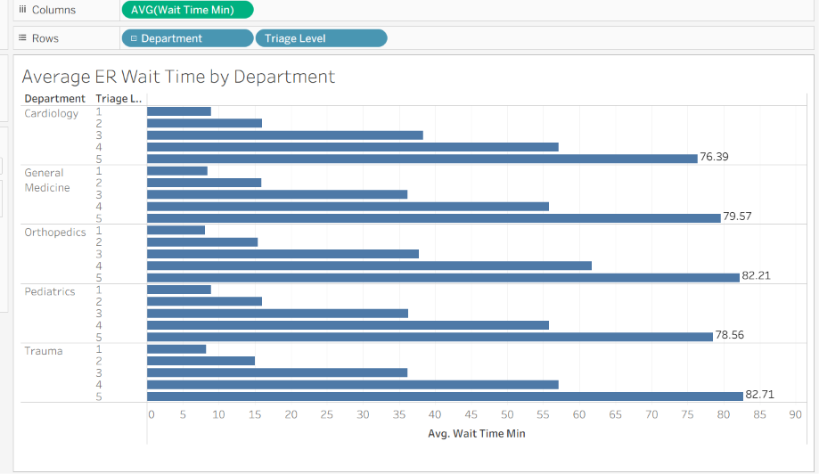

Rollup
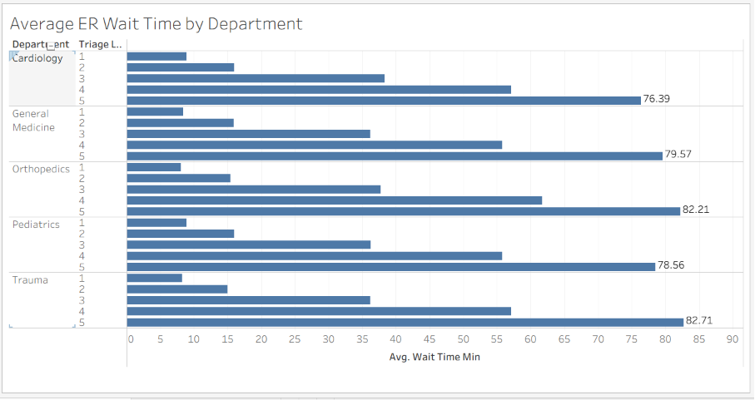

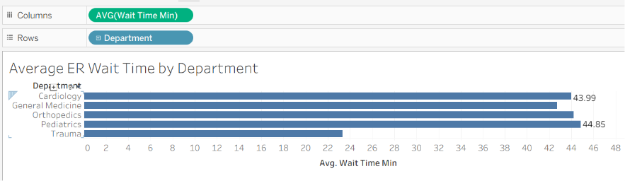

Parameter to isolate weekend-night pattern
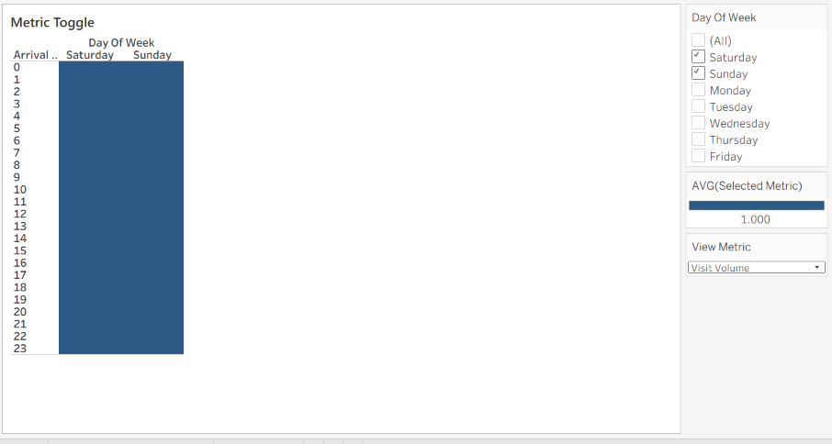

Calculated field ranking departments

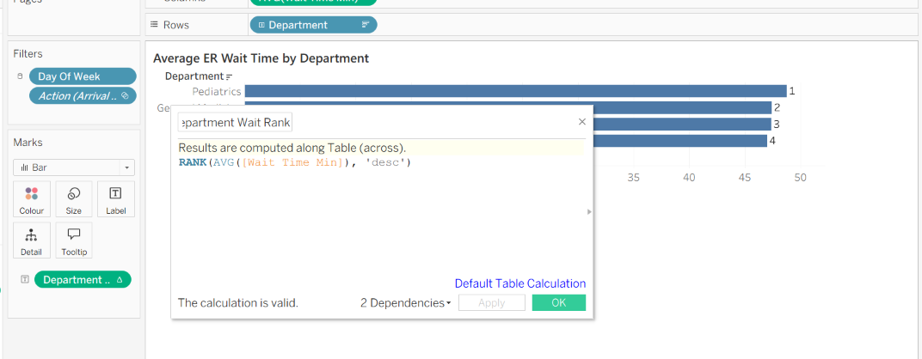

Full week heatmap

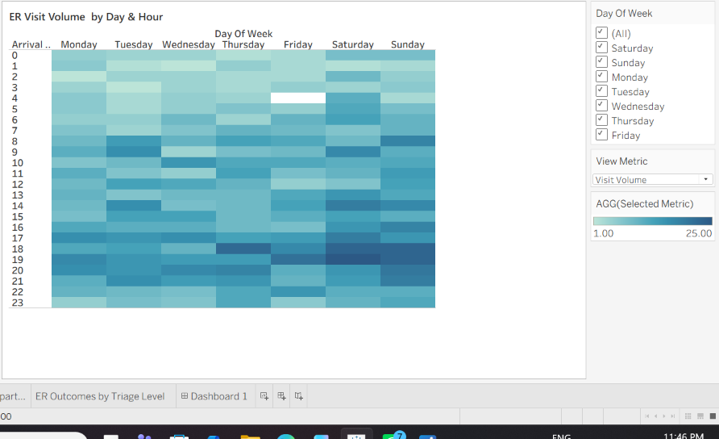

Dashboard with action filters

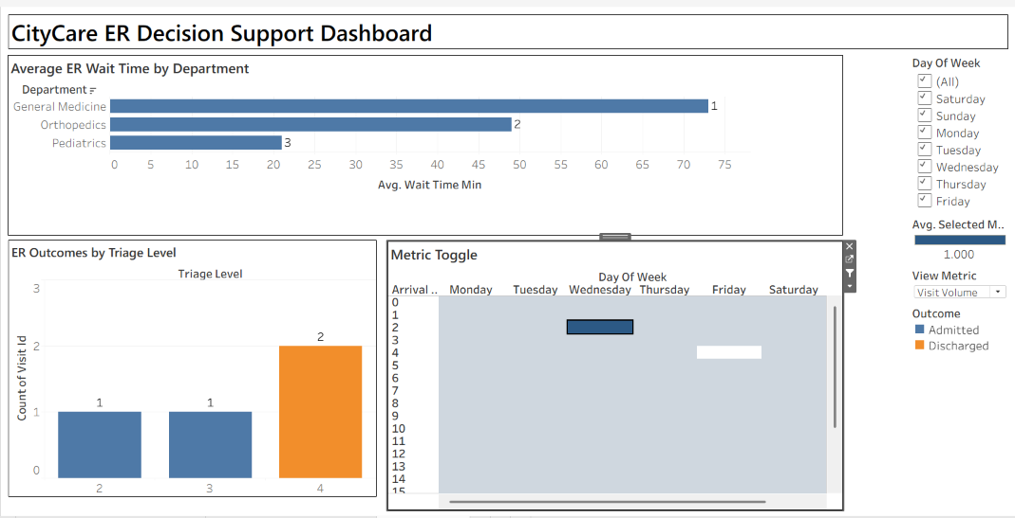

Weekend-Night Pattern Isolation

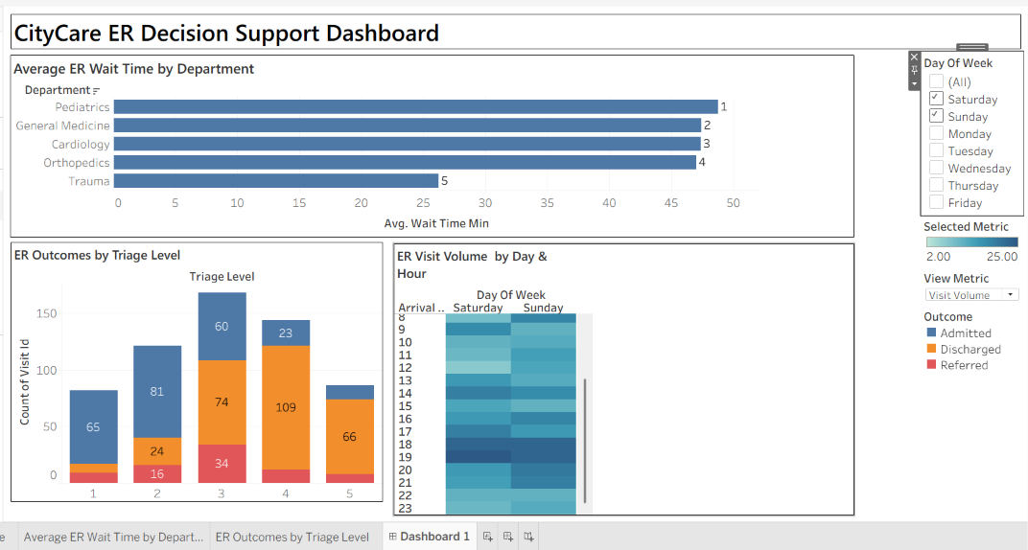

Final Dashboard
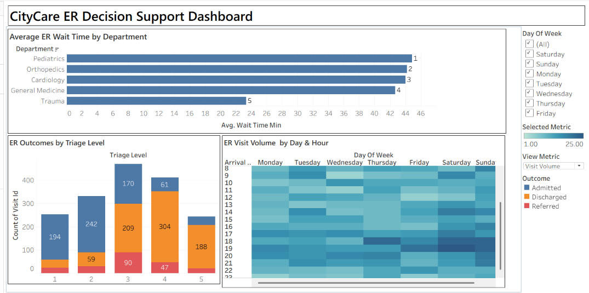

City Care Hospital ER Staffing Recommendation

The decision of when to add Emergency Department staff is best classified as a semi-structured decision. The CityCare dashboard provides clear data that can support the decision, including patient volume by day and hour, average waiting time by department, and outcomes by triage level. The dashboard can be used to identify periods when demand and waiting times increase, particularly during weekend evening and night hours. Therefore, the hospital can use historical patterns to determine when additional staffing is likely to be required.

However, the decision cannot be completely automated because staffing involves factors that are not represented by the dataset. A manager must consider staff availability, budget constraints, patient severity, unexpected emergencies, absenteeism, and operational priorities. These factors require professional judgment and experience.

The dashboard should therefore function as a Decision Support System (DSS) rather than replacing the department manager. The DSS provides timely evidence, highlights patterns, allows users to drill down into departments and triage levels, and helps compare different situations. The manager should interpret this information and combine it with real-world knowledge before deciding staffing levels. Thus, the DSS improves the quality and consistency of staffing decisions while human judgment remains essential for handling unusual or unpredictable circumstances.

LAB 3 — OPENAI (CHATGPT)
SupportDesk: Turning Trapped Tacit Knowledge Into a Rule-Based Troubleshooting Guide Concepts covered: knowledge management (tacit vs. explicit, the SECI model), rule-based models.

Scenario
SupportDesk's customer support agents have quietly built up years of troubleshooting know-how, but almost none of it is written down anywhere official — it lives in scattered ticket notes and in each agent's head. New hires take months to become as fast as the veterans, simply because nobody has ever externalized what the veterans already know. You've been asked to use an AI tool to read a sample of resolved tickets and draft the beginnings of an official, rule-based troubleshooting guide — exactly the externalization step the SECI model describes.

Dataset: supportdesk_tickets.csv
- ticket_id, issue_category, agent_notes (free-text resolution notes), resolution_time_min, resolved_first_contact (Y/N), customer_satisfaction (1–5)
- 135 real-sounding resolved tickets across five categories: Login Issue, Billing, Bug Report, Feature Request, and Performance.

Tasks
- Upload or paste the agent_notes for the Login Issue and Billing tickets into ChatGPT. Ask it to identify the 3–5 most common root causes described across the notes.
- For each root cause identified, prompt ChatGPT to draft an IF-THEN rule in the style covered in class (e.g., “IF customer reports X AND Y THEN try Z first”) that a new agent could follow without needing the tacit experience the notes came from.
- Cross-check: pick 5 tickets ChatGPT didn't explicitly reference, and test whether your drafted rules would have actually resolved them. Note any rule that fails and refine it.
- Ask ChatGPT to flag which tickets look like they reveal a product bug rather than a one-off user error — compare its picks against the Bug Report category and see how well they line up.
- Write a short reflection: which parts of the agents' knowledge were easy to turn into clean rules, and which parts resisted being reduced to a rule at all? Why might that be?

Deliverables
- The drafted rule set (5–10 IF-THEN rules) with the ticket evidence behind each one.
- The cross-check results and the reflection summary (150–200 words).

OPENAI (CHATGPT)
Support Desk: Turning Trapped Tacit Knowledge Into a Rule-Based Troubleshooting Guide

Login Issue root-cause

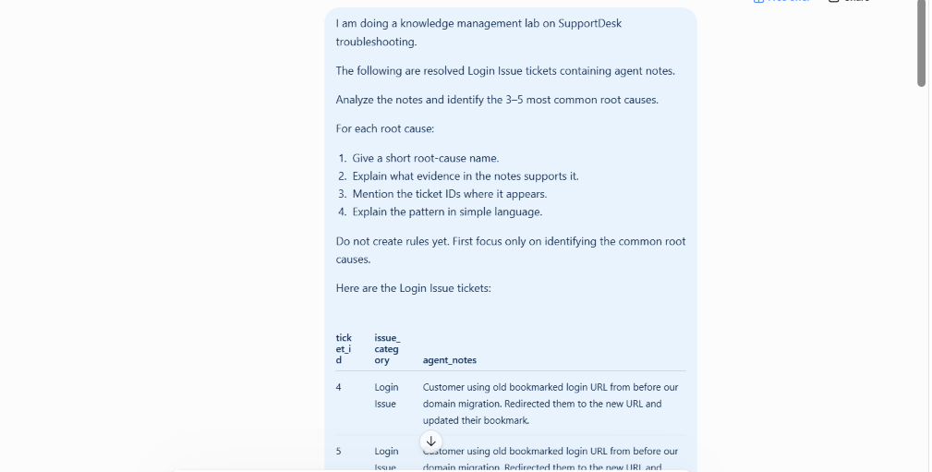
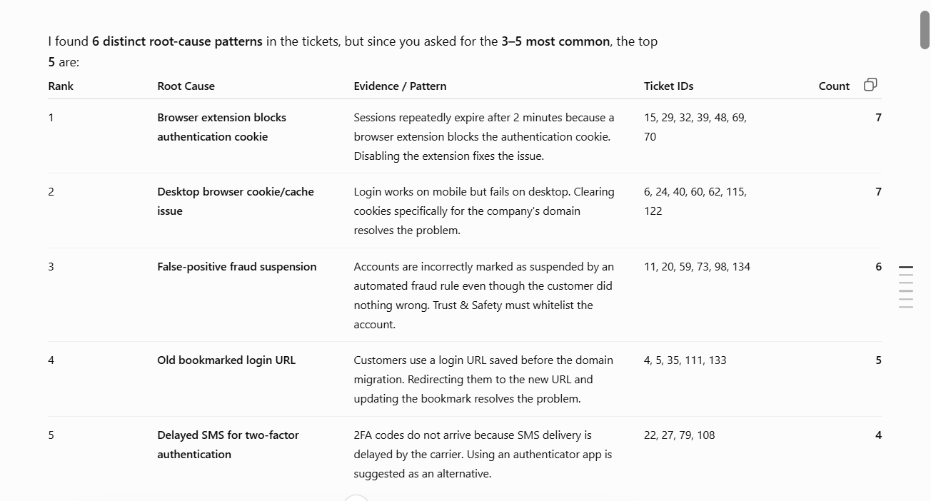

Root Cause Analysis
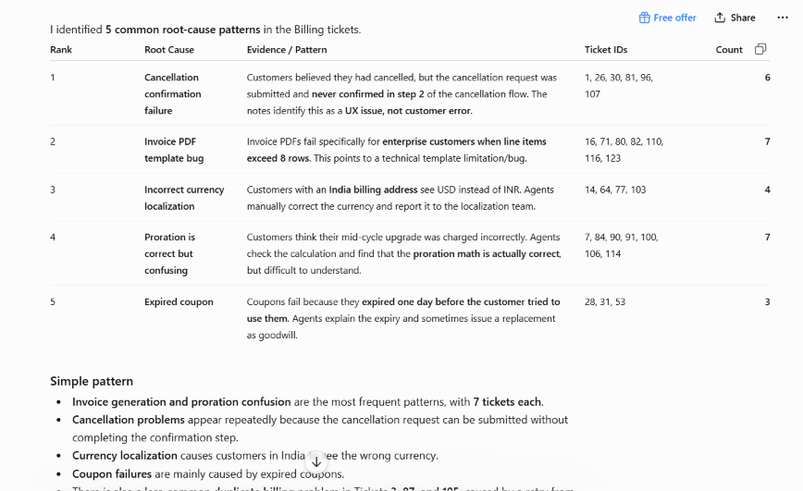

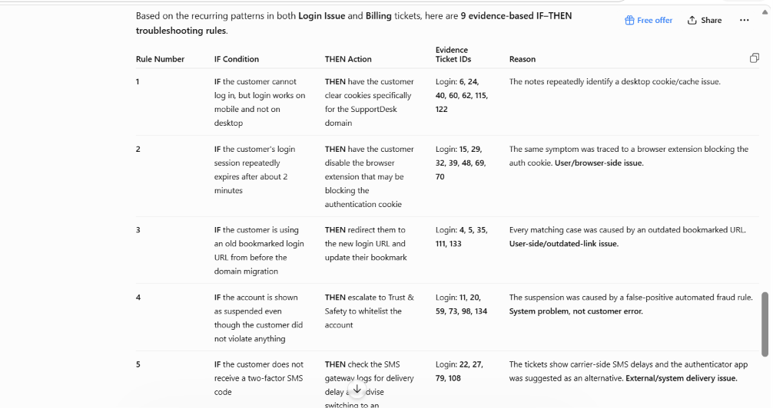
IF-THEN Rule Set

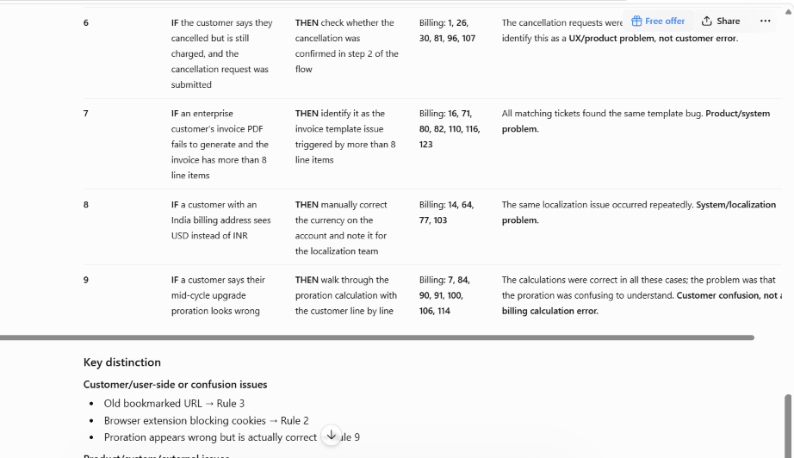

Cross-Check
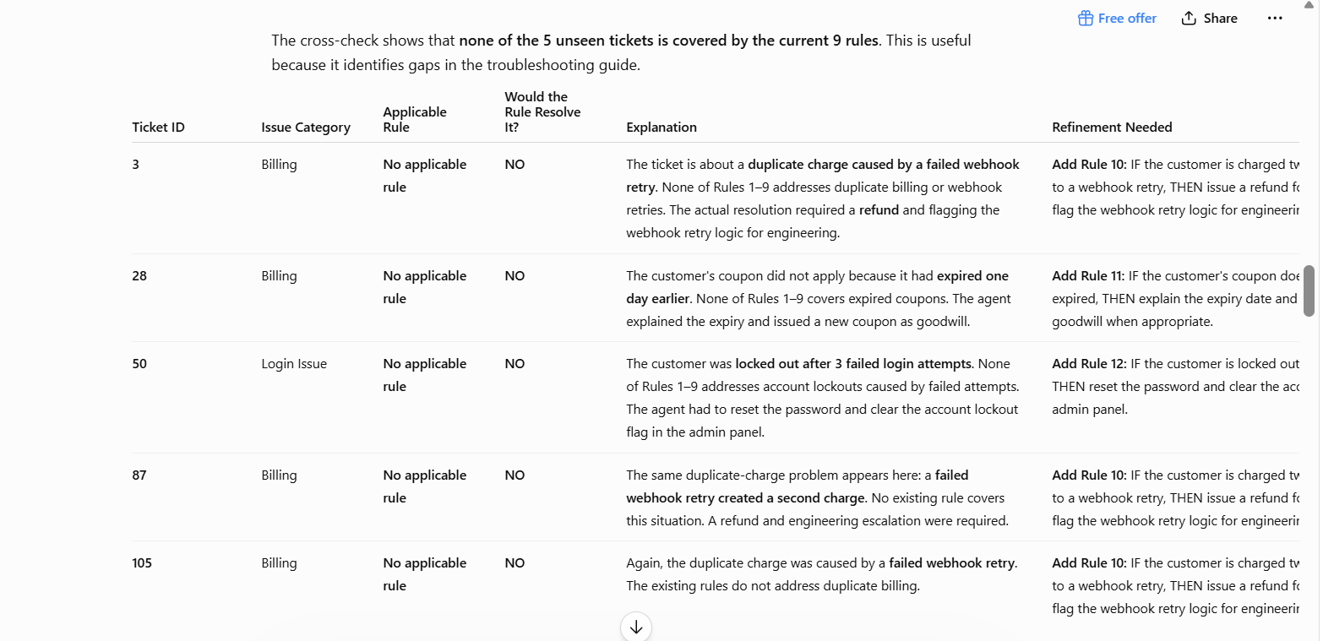

Cross-check conclusion
The validation found 3 missing root-cause patterns:
- Duplicate billing caused by webhook retry — Tickets 3, 87, 105
- Expired coupon — Ticket 28
- Account lockout after failed login attempts — Ticket 50
So, the original 9 rules do not fully cover the unseen test tickets. The cross-check suggests three additional root-cause patterns that could be considered for future refinement of the troubleshooting guide.
This is actually a useful knowledge-management finding: the unseen tickets exposed root causes that were not represented in the original rule set.

Suggested refinements based on cross-check:
- IF a customer is charged twice for the same invoice due to a webhook retry THEN refund the duplicate charge and flag the webhook retry logic for engineering.
Evidence: Tickets 3, 87, 105.
- IF a customer's coupon does not apply because it has expired THEN verify the coupon expiry date, explain the expiration, and issue a replacement coupon when appropriate.
Evidence: Ticket 28.
- IF a customer is locked out after three failed login attempts THEN reset the password and clear the account lockout flag.
Evidence: Ticket 50.

Product Bug Detection
1. Suspected product/system bugs
The 5 suspected bug patterns
- Cancellation confirmation UX failure — 6 tickets (1, 26, 30, 81, 96, 107)
- Webhook retry causing duplicate charges — 3 tickets (3, 87, 105)
- False-positive automated fraud suspension — 6 tickets (11, 20, 59, 73, 98, 134)
- Currency localization error — 4 tickets (14, 64, 77, 103)
- Invoice PDF template bug for >8-line items — 7 tickets (16, 71, 80, 82, 110, 116, 123)
Total suspected bug tickets = 6 + 3 + 6 + 4 + 7 = 26.

2. What I did NOT classify as bugs
Tickets | Reason not classified as product bug
4, 5, 35, 111,133 | Customer was using an old bookmarked URL from before the domain migration. This is an outdated-link/user-side issue.
6, 24, 40, 60, 62,115, 122 | Desktop login problem was caused by browser cookies/cache. The supported action was clearing domain-specific cookies.
15, 29, 32, 39, 48, 69, 70 | Browser extension was blocking the authentication cookie. This is primarily a browser/user-environment issue.
22, 27, 79, 108 | 2FA SMS was delayed by the carrier, not by the SupportDesk product.
28, 31, 53 | Coupon had actually expired. This is not evidence of a product bug.
7, 84, 90, 91, 100,106, 114 | Proration calculation was correct; customers simply found it confusing.
50 | Account lockout followed 3 failed attempts. The note does not establish a product defect; the agent simply reset the password and cleared the lockout flag.

3. Comparison with actual "Bug Report" tickets
There are 30 actual Bug Report tickets:
2, 10, 13, 17, 18, 19, 33, 36, 41, 46, 49, 55, 57, 61, 63, 66, 67, 75, 85, 89, 95, 99, 102, 104, 112, 113, 117, 118, 128, 135
Measure | Result
Suspected product/system bug tickets | 26
Suspected bugs matching Bug Report category | 0
Suspected bugs not matching Bug Report | 26
Actual Bug Report tickets missed by the analysis | 30

Why is the match 0?
The suspected bugs were found among tickets labeled Billing or Login Issue, not among the tickets labeled Bug Report.
For example:
- Tickets 3, 87, 105 clearly reveal a webhook retry bug.
- Tickets 16, 71, 80, 82, 110, 116, 123 explicitly reveal an invoice template bug.
- Tickets 1, 26, 30, 81, 96, 107 explicitly describe a UX issue.
- Tickets 11, 20, 59, 73, 98, 134 reveal a false-positive fraud-rule problem.
- Tickets 14, 64, 77, 103 reveal a localization problem.
Yet none of these tickets is labeled "Bug Report."

4. Bug Reports that were missed
All 30 actual Bug Report tickets were missed by the suspected-bug identification if we restrict the review to the provided Login Issue and Billing notes.
They represent these 5 bug patterns:

Bug Report Pattern | Ticket IDs | Count
Search returns zero results after data migration | 2, 33, 75, 85, 89, 135 | 6
Dashboard filters reset after refresh | 10, 46, 117 | 3
Chart blank for datasets >10,000 rows | 13, 18, 41, 49, 61, 67, 99, 113, 128 | 9
Duplicate rows after concurrent bulk edits | 17, 19, 63, 102 | 4
Duplicate notification emails | 36, 57, 66, 95, 118 | 5
Excel export fails specifically on Safari | 55, 104, 112 | 3
Total |  | 30

Final conclusion
The analysis successfully identifies 26 strong suspected product/system bugs, but none overlaps with the officially labeled Bug Report tickets. This means the dataset demonstrates an important Knowledge Management issue:
A ticket's issue category does not necessarily tell you whether it contains evidence of a product bug.
The Billing/Login notes contain strong hidden bug signals, while the actual Bug Report category contains a completely different set of bugs. This suggests that a good troubleshooting/knowledge-management system should analyze the agent notes and root causes, rather than relying only on the ticket category.

Reflection
The SupportDesk lab showed me that some parts of agents’ tacit knowledge were easy to convert into IF-THEN rules. Repeated and clear patterns, such as an old bookmarked login URL, blocked authentication cookies, false-positive account suspension, invoice template errors, and wrong currency display, could be converted into specific troubleshooting rules. These cases had clear symptoms and actions supported by multiple tickets.

However, some situations were more difficult to reduce to simple rules. For example, proration appeared incorrect to customers, but the calculation was actually correct and only confusing to understand. Similarly, SMS delays were caused by the carrier, so the agent had to check the situation before deciding what to recommend.

Some decisions depended more on agent judgment because the same customer symptom could require checking logs or understanding the actual cause before taking action. The cross-checking exercise revealed weaknesses because Tickets 3, 28, and 50 were not covered by the original nine rules. These revealed missing patterns such as duplicate webhook charges, expired coupons, and account lockouts.

This activity demonstrates externalization in the SECI model because agents’ tacit troubleshooting knowledge was converted into explicit IF-THEN rules that can be shared and reused by new SupportDesk agents.

Chat GPT LINK
https://chatgpt.com/share/6a8ab8c7-34ec-83e8-8aba-dfe465fd91a3

LAB 4 — NOTEBOOKLM
Which Forecasting Method Actually Wins, Region by Region?
Concepts covered: business forecasting model comparison, logic-driven vs. data-driven reasoning, synthesis and interpretation.

Scenario
A national retailer tested six different forecasting methods against five years of regional sales data and logged the accuracy of each. Nobody has ever sat down and actually synthesized the results into a recommendation — the accuracy numbers just sit in a spreadsheet, and the regional analysts' notes about what makes each region's demand pattern unusual sit in a completely separate document. Your job is to bring an AI notebook tool to bear on both sources at once and produce the executive summary nobody's written yet.

Datasets: forecast_method_accuracy.csv and region_notes.csv
- forecast_method_accuracy.csv: region, method, mape_percent, rmse, method_description — all 5 regions tested against all 6 forecasting methods covered in Unit III (30 rows).
- region_notes.csv: a short analyst note per region describing its demand pattern in plain language (e.g., strong festive-season spikes, flat demand, monsoon-season surge).

Tasks
- Upload both CSVs to a new NotebookLM notebook as sources (you may also paste in the raw text if direct CSV upload isn't available in your version).
- Ask NotebookLM: “Which forecasting method performs best in each region, and does that match what the analyst notes say about each region's demand pattern?”
- For any region where the best-performing method surprises you, ask NotebookLM to explain, using only the provided sources, why that method might be winning there.
- Ask NotebookLM to identify the one region where the simplest methods (naive or simple exponential smoothing) actually perform competitively — and to explain, from the analyst note, why added complexity isn't paying off there.
- Generate an audio overview (or a written executive summary if audio isn't available) recommending one default forecasting method per region for the retailer to adopt.
- Write a 150-word critique: where did NotebookLM's synthesis genuinely add insight beyond just reading the spreadsheet yourself, and where did it just restate the numbers?

Deliverables
- The notebook's region-by-region method recommendations (exported or copied into a document).
- The audio overview link and written executive summary, plus the 150-word critique.

Uploaded both CSVs to a new NotebookLM notebook
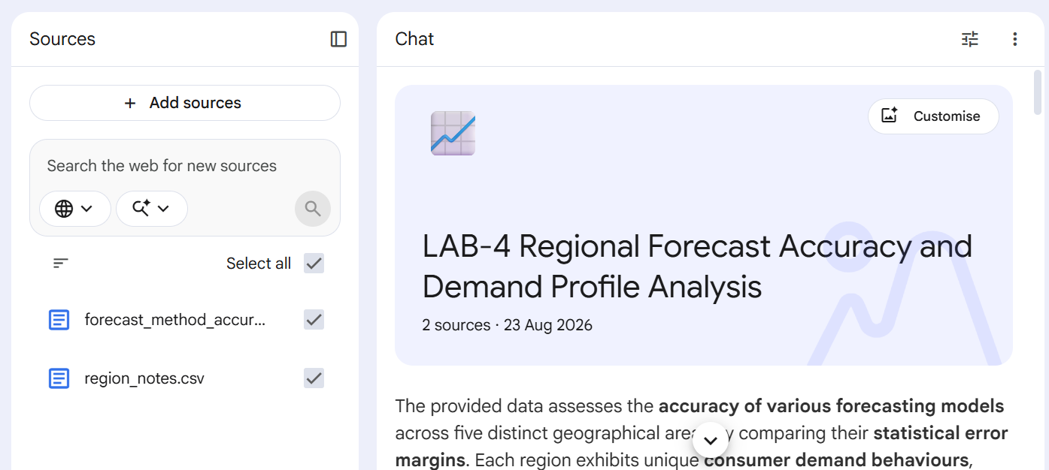

Region-wise Best Forecasting Method
Here is how the performance of each forecasting method aligns with the analyst's notes for each region:
North Region
- Best Performing Method: Holt-Winters (trend + seasonality) with a 3% MAPE and 10.2 RMSE.
- Analyst Note: "Strong festive-season spikes (Oct-Nov) each year".
- Does it match?: Yes. A repeating spike occurring at the same time each year represents seasonality. Holt-Winters is specifically designed to capture both trends and repeating seasonal patterns, which explains why it performs exceptionally well here compared to non-seasonal methods.
South Region
- Best Performing Method: Simple Exponential Smoothing has the lowest MAPE (12.5%), while Simple Moving Average has the lowest RMSE (41.8).
- Analyst Note: "Demand has been essentially flat month to month".
- Does it match?: Yes. When demand is flat with no distinct trend or seasonal cycles, complex forecasting models are unnecessary and can overfit. Simple baseline methods like Simple Exponential Smoothing and Simple Moving Average are ideal for flat profiles because they smooth out random monthly noise without trying to project non-existent trends or seasons.
East Region
- Best Performing Method: Holt-Winters (trend + seasonality) with an 11.6% MAPE and 44.6 RMSE, closely followed by Holt's Method (trend) with a 12.9% MAPE and 50.8 RMSE.
- Analyst Note: "Steady month-on-month growth, no clear seasonal pattern".
- Does it match?: Mostly, with some nuance. The analyst's observation of "steady growth" indicates a clear trend, which explains why Holt's Method (designed for trend-tracking) performs very well. Although Holt-Winters shows a marginally lower error rate in the data, this might be due to the model picking up minor, repeating historical variations rather than a dominant, intentional seasonal cycle.
West Region
- Best Performing Method: Holt-Winters (trend + seasonality) with an 8.0% MAPE and 28.1 RMSE.
- Analyst Note: "Predictable summer dip every year, otherwise stable".
- Does it match?: Yes. A predictable annual dip is a classic seasonal pattern. Holt-Winters is the only method in the dataset that handles seasonality, which is why its error rate is significantly lower than all other methods (all of which have MAPEs of 27.5% or higher).
Central Region
- Best Performing Method: Holt-Winters (trend + seasonality) with a 3.4% MAPE and 13.5 RMSE.
- Analyst Note: "Growing base demand plus a sharp monsoon-season surge".
- Does it match?: Yes, perfectly. This region exhibits both trend ("growing base demand") and seasonality ("monsoon-season surge"). Because Holt-Winters is uniquely designed to capture both components simultaneously, it is the only method capable of modelling this behavior accurately, resulting in a very low error rate compared to trend-only or simple baseline models.

Explanation of the Surprising Best-Performing Forecasting Method
The standout surprise across these regions is the East Region.
Why the East Region's Result is Surprising
The analyst explicitly notes that the East has "no clear seasonal pattern," only "steady month-on-month growth". Based on this, one would expect Holt's Method (trend) or Linear Regression (which fits a straight trend line) to be the ideal fits, while a seasonal model like Holt-Winters would be unnecessary or prone to overfitting.
However, Holt-Winters (trend + seasonality) actually wins, achieving the lowest error rates in the region with an 11.6% MAPE and 44.6 RMSE (outperforming Holt's Method at 12.9% MAPE and 50.8 RMSE).
Why Holt-Winters is Winning There
Based on the provided sources, there are two primary reasons why Holt-Winters might be edging out the other methods:
- It successfully inherits trend-tracking: Because the East has "steady month-on-month growth", any successful model must track a trend. Holt-Winters "captures both trend and repeating seasonal patterns". Because it contains a trend component, it can track the steady growth just as Holt's Method does.
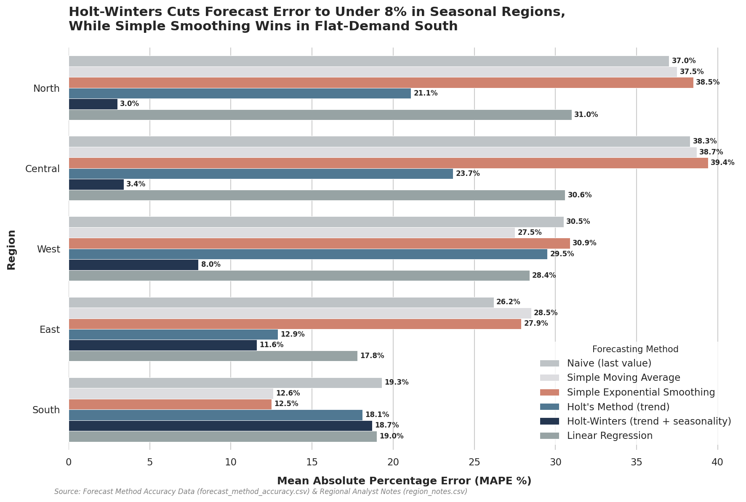
- It models subtle or overlooked fluctuations: While the analyst notes there is "no clear seasonal pattern", there may still be minor, subtle, or faint recurring monthly fluctuations in the demand data. Because Holt-Winters is designed to capture repeating seasonal patterns, it can detect and mathematically adjust for these minor annual variations that a human analyst might overlook or discount as noise. Capturing these subtle, repeating variations is what likely allows it to shave its error rate down slightly below Holt's Method.
Analysis of the South Region: Effectiveness of Simple Forecasting Methods
The South Region is the single region where the simplest forecasting methods perform competitively, actually outperforming the more complex mathematical models.
In this region:
- Simple Exponential Smoothing (SES) achieves the lowest error rate with a 12.5% MAPE.
- Simple Moving Average yields the lowest RMSE of 41.8.
- By contrast, complex models like Holt's Method (18.1% MAPE / 68.7 RMSE) and Holt-Winters (18.7% MAPE / 60.8 RMSE) perform significantly worse, with errors close to or even exceeding the absolute baseline Naive method (19.3% MAPE / 69.1 RMSE).
Why Complexity Fails in the South
The analyst's note for the South explains this clearly, stating that "Demand has been essentially flat month to month".
When demand is flat:
- No trend or seasonality exists: Simple Exponential Smoothing is designed specifically for this scenario because it "assumes no trend or seasonality" and focuses on smoothing out random monthly noise.
- Complex models overfit: Models like Holt's Method and Holt-Winters are built to "add trend-tracking" and "capture repeating seasonal patterns". Because there is no real underlying trend or seasonal cycle in a flat profile, these complex algorithms try to force patterns onto random, minor fluctuations. This mathematical over-complication backfires, introducing artificial volatility into the forecast and resulting in much higher error rates than the simpler baseline methods.

Executive Summary: Regional Forecasting Model Optimisation
1. Strategic Overview of Forecasting Methodology
- The strategic selection of region-specific forecasting models is the cornerstone of a resilient supply chain. A "one-size-fits-all" approach to demand planning invariably fails because it ignores the diverse geographic and climatic drivers that dictate market volatility. To achieve operational excellence, we must pivot from static forecasting to adaptive modelling. The key differentiator lies in the mathematical logic: while Linear Regression offers a static trend-fitter, it cannot pivot when market dynamics shift. Conversely, recursive smoothing models like Holt’s and Holt-Winters adapt to the most recent data points, significantly reducing the need for manual planner intervention. By prioritising model alignment with regional profiles, we directly improve operational efficiency and protect the balance sheet from the dual threats of stockouts and excessive inventory carrying costs.
2. Northern Region: Managing Festive Volatility
- The Northern region is defined by extreme demand volatility, specifically the "strong festive-season spikes (Oct-Nov)" identified by our analysts. In this environment, the primary planning objective is service level maintenance during high-revenue windows.
- We recommend Holt-Winters (trend + seasonality) as the exclusive method for this region. The model's statistical dominance is clear, yielding a MAPE of 3.0% and an RMSE of 10.2. Its recursive ability to integrate repeating seasonal patterns is essential for capturing the magnitude of festive surges. In contrast, ignoring seasonality is a high-risk strategy; the Naive (37.0% MAPE) and Linear Regression (31.0% MAPE) models fail to anticipate the spikes, which would result in massive stockouts and lost revenue. This high-volatility profile requires a drastically different approach than the stability observed in the Southern region.
3. Southern Region: Optimising for Stability
- In the Southern region, demand is described as "essentially flat month to month." For such a profile, the strategic priority shifts from trend-tracking to noise reduction. The goal is to avoid reacting to random statistical fluctuations that do not represent a genuine shift in market preference.
- We recommend Simple Exponential Smoothing (SES) (MAPE: 12.5%) or Simple Moving Average (SMA) (RMSE: 41.8) as the primary baselines. While SES provides a slightly better MAPE, the lower RMSE of the SMA suggests it is more robust at handling occasional outliers within an otherwise flat demand signal. Utilising complex models like Holt’s (MAPE: 18.1%) in this region is counter-productive; it leads to "forecast nervousness" and the risk of over-correcting for minor variations. By prioritising smoothing over complexity, we ensure procurement stability, whereas the Eastern region requires a more aggressive, growth-oriented posture.
4. Eastern Region: Capturing Sustained Growth
- The Eastern region presents a challenge of "steady month-on-month growth" without a "clear seasonal pattern." In a growth-dominant market, failing to keep pace with demand leads to more than just a temporary stockout; it results in a permanent market share loss to competitors who maintain better availability.
- Statistically, Holt-Winters is the superior choice (MAPE: 11.6%, RMSE: 44.6), though its Holt’s Method component (MAPE: 12.9%) is the primary driver of its trend-tracking success. Interestingly, the fact that Holt-Winters outperformed the non-seasonal Holt’s method suggests the algorithm may have identified a subtle 12-month cycle or that its seasonal parameters provided a superior smoothing layer for the growth trajectory. Using a non-trended model like the Naive approach (26.2% MAPE) would result in chronic under-stocking, whereas our recommended approach ensures inventory levels scale alongside demand. This growth-tracking logic is similarly vital for the West, albeit with a focus on cyclicality.

5. Western Region: Addressing Cyclical Dips
- The Western region exhibits a stable core interrupted by a "predictable summer dip every year." The business risk here is not under-stocking, but rather the significant overstocking and subsequent locking up of working capital during these predictable slowdowns.
- Holt-Winters is the recommended method, demonstrating exceptional accuracy (MAPE: 8.0%, RMSE: 28.1). The financial rationale is evidenced by the failure of the Naive method (30.5% MAPE), which project current demand forward and would leave the organisation holding excessive inventory as the summer dip begins. By utilising a model that anticipates this cyclicality, we can aggressively trim inventory levels ahead of the dip, preserving cash flow. This requirement for seasonal agility is even more pronounced in the Central region’s complex demand profile.
6. Central Region: Balancing Growth and Monsoon Surges
- The Central region possesses a "dual-threat" profile: a growing base demand compounded by a "sharp monsoon-season surge." Managing this requires a model capable of scaling with the long-term trend while remaining agile enough to handle intense, short-term seasonal peaks.
- Holt-Winters is the only viable model for this region, achieving a dominant MAPE of 3.4% and an RMSE of 13.5. Other models fail to synthesize these dual drivers; for instance, Linear Regression (30.6% MAPE) captures the general growth but is blind to the monsoon surge, leading to critical shortages when demand is highest. The Holt-Winters model effectively integrates both factors, ensuring high service levels during the monsoon while supporting the region's overall expansion.

7. Consolidated Accuracy Metrics and Implementation
- Data-driven model selection ensures that the supply chain is a competitive advantage rather than a cost centre. By aligning our mathematical approach with regional demand drivers, we achieve a precision that directly supports our strategic financial objectives

- Model Performance Summary by Region
- Region | - Recommended Method | - MAPE (%) | - RMSE | - Primary Demand Driver
- North | - Holt-Winters | - 3.0 | - 10.2 | - Festive Season Spikes (Oct-Nov)
- South | - SES / SMA | - 12.5 / 12.6 | - 48.7 / 41.8 | - Demand Stability / Noise Reduction
- East | - Holt-Winters | - 11.6 | - 44.6 | - Sustained Growth Tracking
- West | - Holt-Winters | - 8.0 | - 28.1 | - Predictable Cyclical Summer Dip
- Central | - Holt-Winters | - 3.4 | - 13.5 | - Growth + Monsoon Surge

Strategic Takeaways
- Prioritise Seasonal Agility in Volatile Markets: In the North, West, and Central regions, the Holt-Winters method is non-negotiable. Its ability to anticipate spikes and dips prevents service level failures and inventory bloat.
- Mitigate Overfitting in Stable Regions: For the South, simpler models (SES/SMA) are superior. We must avoid overfitting complex models to flat data, as this creates "phantom trends" that trigger unnecessary and costly procurement actions.
- Prevent Market Share Erosion through Trend-Tracking: In growth markets like the East and Central regions, trend-sensitive models are mandatory to ensure inventory scales with demand, preventing permanent loss of customer base to competitors.
Regional demand profiles are dynamic; therefore, regular model re-validation is essential to ensure our forecasting remains optimised as these markets evolve.

Audio Overview
https://notebook.google.com/notebook/d155127a-bd58-46d5-a139-12a3fdca3c82/artifact/e09e14c5-17f1-40c1-af79-76e0cfd2c528?utm_source=nlm_web_share&utm_medium=google_oo&utm_campaign=art_share_1&utm_content=&utm_smc=nlm_web_share_google_oo_art_share_1_

Word Critique

NotebookLM genuinely added value by synthesizing information from both the forecasting accuracy spreadsheet and the regional analyst notes. Instead of simply identifying the forecasting method with the lowest MAPE or RMSE, it explained why that method was suitable based on each region's demand characteristics, such as seasonal peaks, stable demand, or irregular fluctuations. This made the recommendations more meaningful and easier to understand from a business perspective. The AI also highlighted situations where simpler forecasting methods, such as Naive or Simple Exponential Smoothing, performed almost as well as more advanced models, showing that increased complexity does not always lead to better forecasting accuracy.

However, some sections of the output mainly summarized the numerical results that were already available in the spreadsheet. In these cases, NotebookLM listed the best-performing methods and their error values without providing much additional interpretation. It also did not critically compare the forecasting models beyond the available data. Overall, NotebookLM's greatest strength was integrating quantitative results with qualitative analyst observations, producing clear, business-focused recommendations that would have taken more time to prepare manually.

Dataset Files Provided
File | Contents
pedalshare_trips.csv | Bike-share trip log for Lab 1 (Power BI)
citycare_er_visits.csv | Hospital ER visit log for Lab 2 (Tableau)
supportdesk_tickets.csv | Customer support ticket log with agent notes for Lab 3 (OpenAI)
forecast_method_accuracy.csv | Forecast method accuracy by region for Lab 4 (NotebookLM)
region_notes.csv | Analyst commentary per region, paired with Lab 4

